An Integrated Business Intelligence for Sales Forecasting and Inventory Management

A Capstone Project Presented to the Faculty of
Institute of Computing Studies and Library Information Science
City College of Angeles
Angeles City



In Partial Fulfillment of the Requirement for the Degree
Bachelor of Science in Information Systems

By:

Clark Justine T. Basco
Christian M. Cunan
Harold P. Dalusung
Halden H. Niguidula
Adrian Jury C. Pineda
Fredrick Matthew Pineda

October 2026

INTRODUCTION

Background of the Study
Technology is constantly evolving, and the retail business sector is no exception. In the modern globalized economy, the transition from traditional, manual operations to digitized frameworks is no longer a luxury but a competitive necessity. To address these global operational challenges, the United Nations established the Sustainable Development Goals (SDGs), specifically highlighting SDG 9 (Industry, Innovation, and Infrastructure), which emphasizes the need to upgrade the technological capabilities of enterprises, and SDG 12 (Responsible Consumption and Production), which targets the reduction of retail waste and commercial spoilage (United Nations, 2024). Globally, enterprises handling fast-moving consumer goods (FMCG) are shifting toward data-driven inventory management to prevent overstocking and minimize financial losses from expired products (F1000Research, 2024).
In the Philippines, local grocery stores operating within bustling public markets play a vital role in sustaining community economies. However, many of these small and medium enterprises (SMEs) still rely heavily on traditional pen-and-paper methods for their daily operations (Asian Development Bank, 2025; Department of Trade and Industry, 2024). The manual recording of hundreds of daily transactions involving canned goods, dry commodities, and household essentials is highly prone to human error. Without a centralized system to track fast-moving items and monitor approaching expiration dates, these traditional businesses often suffer from inaccurate stock counts, leading to unexpected stockouts of high-demand products and the costly disposal of expired goods (Villanueva & Reyes, 2025).
This operational gap is highly evident at Sharon Store, a retail grocery business located in the Pampang Public Market, Angeles City, Pampanga. Operating since 2017 with a workforce of 8 operational employees and 2 managing owners, the store currently manages its extensive daily inventory and sales transactions through physical logbooks. This manual approach makes it nearly impossible for the management to instantly determine the exact quantity of available goods or accurately predict future consumer demand for daily staples. Consequently, the business faces challenges in optimizing its wholesale purchasing, often relying on physical estimations rather than concrete data, which ultimately hampers its operational efficiency and economic growth (RSIS International, 2026).
To resolve these critical inefficiencies, this project proposes the development of a Web-Based Inventory and Sales Forecasting System tailored specifically for Sharon Store. By transitioning from a manual recording process to an automated digital database equipped with a Point of Sale (POS) transaction interface and a Business Intelligence Dashboard, the management will gain real-time visibility into their stock levels. Furthermore, the integration of a sales forecasting module will empower the owner to make data-driven purchasing decisions, ensuring that essential grocery products are consistently available while drastically reducing the financial hemorrhage associated with unsold, expired merchandise.

Statement of the Problem
The study seeks to address the issues arising from the continued use of manual inventory and record-keeping processes at Sharon Store. Specifically, it aims to answer the following problems
- The inventory process is inefficient due to reliance on manual procedures, resulting in data redundancy and inaccurate stock levels.
- The current manual system increases the likelihood of financial losses due to spoilage (overstocking) or missed sales opportunities (understocking) caused by the lack of predictive forecasting tools.
- Sensitive transaction data and historical sales records are stored in physical logbooks, making data management vulnerable to loss, damage, or unauthorized access.
- The absence of an integrated Business Intelligence dashboard limits the management's ability to visualize real-time sales performance and identify market trends for immediate decision-making.

Objectives of the Study

The general objective of the study is to develop and implement a Web-Based Inventory and Sales Forecasting System with Business Intelligence Dashboard for Sharon Store that streamlines inventory processes, improves the accuracy of sales predictions, and enhances data visualization for the management of fast-moving consumer goods, dry commodities, and household essentials at the Pampang Public Market. Specifically, it aims:
- To design and implement an automated inventory module that reduces the time and effort required to monitor stock levels compared to the current manual system.
- To integrate a sales forecasting module that improves the accuracy and reliability of predicting future demand based on historical data.
- To establish a secure digital storage and retrieval mechanism with regular backups to protect sensitive business transaction records.
- To provide an integrated Business Intelligence (BI) Dashboard accessible to management, enabling them to visualize sales trends, fast-moving items, and critical stock levels in real-time.

Scope of the Study
This study focuses on the design, development, and implementation of a Web-Based Inventory and Sales Forecasting System for Sharon Store, specifically located in the Pampang Public Market, Angeles City, Pampanga. The study emphasizes improving data accuracy, forecasting reliability, and security compared to the current manual processes. The implementation and evaluation of the system will occur within one academic year, focusing on its functionality, usability, and security, as well as stakeholder satisfaction.
The modules covered by the study are arranged according to the users of the system. For the System Administrator or Owner, the system includes a Business Intelligence Dashboard Module, which is a graphical interface that allows the owner to visualize real-time sales performance, track fast-moving grocery items, and monitor overall inventory health. It also features a Sales Forecasting Module, a data analysis tool that processes historical sales data to predict future consumer demand for daily staples and generate optimal restocking recommendations. Furthermore, an Inventory Management Module provides full control to add, update, and categorize grocery products (such as canned goods, dry commodities, and household essentials), and strictly track stock levels in pieces, packs, or kilograms.
For the Staff, the system provides a Point of Sale (POS) Module integrated with barcode scanning capabilities. This serves as a rapid transaction interface used to scan items, instantly record daily sales, process customer purchases, and automatically deduct sold grocery items from the active inventory to ensure fast checkout speeds.

Delimitations of the Study
To maintain strict alignment with Information Systems principles and ensure project feasibility, the system boundaries explicitly exclude several key areas. First, regarding excluded business operations, the system operates strictly as a specialized inventory and sales management tool; it completely excludes administrative tasks such as employee payroll processing, official BIR tax generation, and online customer e-commerce or delivery tracking. Second, concerning procurement, while the system monitors stock levels and provides data-driven recommendations for restocking, it fundamentally requires manual procurement. The system will not autonomously order goods; the management must still physically purchase from wholesale suppliers to negotiate prices and inspect product conditions. Furthermore, in terms of hardware integration, the system is strictly limited to standard USB or Bluetooth barcode scanners to expedite the POS checkout process. The system explicitly excludes integration with other proprietary Point of Sale (POS) peripherals such as automated receipt printers, electronic cash drawers, or physical anti-theft security tags. Third, regarding physical enforcement, the system is decoupled from anti-theft hardware. It does not integrate with physical security tags, CCTV cameras, or hardware sensors to monitor shoplifting within the grocery store. Finally, concerning forecasting constraints, the predictive module relies exclusively on historical sales data. It does not autonomously account for sudden external anomalies such as supplier shortages, rapid economic inflation, or localized panic buying during natural calamities.

Conceptual Framework
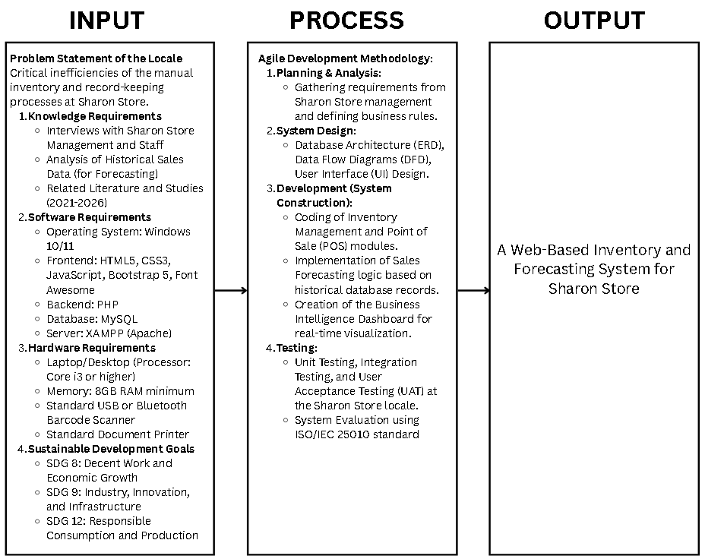
Figure 1. IPO Diagram
The Input phase identifies the foundational requirements of the study, including the current manual inventory processes, historical sales data, and necessary hardware and software. The Process phase follows the Agile Development Methodology, working through iterative cycles of requirements planning, system design, system construction, and rigorous testing utilizing the ISO/IEC 25010 standard. Finally, the Output phase delivers the fully functional, web-based digital solution designed to drive operational innovation and economic growth for the enterprise.

Significance of the Study
The development of the web-based inventory and forecasting system aims to improve the efficiency, accuracy, and profitability of the business's operations.
- To the Owner (Management): It provides a clear, real-time view of sales and stock levels to prevent financial loss from overstocking perishable grocery goods and allows for data-driven wholesale purchasing.
- To the Staff: It speeds up the daily checkout process during peak market hours and completely eliminates the exhausting task of manually writing down hundreds of daily item transactions in a physical logbook.
- To the Customers: It ensures their preferred daily staples and household necessities are consistently in stock and properly monitored for quality and expiration.
- To the Local Economy: It supports the continuous operation, technological modernization, and economic stability of a local enterprise within the Pampang Public Market.
- To the Researchers and Future Researchers: It serves as a practical reference and foundational guide for students developing future web-based retail systems for fast-moving consumer goods (FMCG).

Definition of Terms
- Business Intelligence Dashboard - It refers to the visual interface within the system that displays real-time charts, graphs, and analytics of sales performance and inventory status.
- Forecasting - It refers to the data analysis function within the system that predicts the quantity of stocks needed for the upcoming period based on historical sales trends.
- Inventory Management - It refers to the module that handles the recording, tracking, and updating of items from delivery to sale.
- Web-Based System - It refers to the software application accessible via a web browser that Sharon Store will use to manage their daily operations.

REVIEW OF RELATED LITERATURE AND STUDY

Foreign Literature
Ladani et al. (2025) discuss the basic structure of web-based inventory and warehouse management systems, particularly the importance of real-time database synchronization for accurate stock monitoring. This is relevant to Sharon Store because the store plans to move from traditional paper-based logbooks to a more organized and automated digital inventory system.
Adetula and Akanbi (2023) emphasize the importance of using predictive analytics to maintain proper inventory levels in small and medium-sized businesses. While Sharon Store will use historical sales data and statistical methods instead of advanced AI, the idea of using data to recommend the right amount of stock can still help prevent overstocking, especially for perishable grocery products.
Ghosh et al. (2022) discuss the use of Business Intelligence (BI) dashboards to present sales trends and important inventory information in an easy-to-understand way. Applying this concept to Sharon Store can help transform its manual inventory records into a more organized digital system while also supporting innovation in small businesses, which is consistent with Sustainable Development Goal 9.
Gunderson et al. (2014) explain different organizational approaches to managing business supplies in retail environments. Their work provides basic inventory control principles that can be applied to small stores when monitoring fast-moving consumer goods and other dry products.
Agboola et al. (2022) show that web-based inventory systems can reduce errors caused by manual recording and improve how resources are managed in small businesses. Their findings support the use of a digital database for local retail stores like Sharon Store to make inventory tracking more accurate and efficient.

Local Literature
Tanaman et al. (2023) highlight the importance of web-based inventory management systems in improving supply chain operations in the Philippines. Their work supports the use of simple and accessible web-based systems for local businesses and vendors that need better ways to manage their inventory.
Bautista and Young (2022) examine inventory management practices in the Philippine food and seasoning industries. They emphasize that proper and systematic stock monitoring can improve the efficiency of product supply and distribution, which is also important for small grocery stores.
German (2016) discusses the shift from traditional inventory monitoring to mobile Point of Sale (POS) applications connected to cloud-based inventory systems. This shows how cloud technology can help micro and small businesses in the Philippines improve their daily operations and keep their inventory records more organized.
Adame et al. (2008) examined early computerized warehouse tracking systems in Iloilo. Their study provides an example of how businesses in the Philippines began moving from manual inventory processes toward computerized systems, showing the long-term need for digital inventory management.
The Ilocos Norte Healthcare Study (2022) examined inventory management practices and their effect on service delivery in local facilities. The study showed that having an organized system for monitoring supplies can improve overall operational performance, which can also be applied to other types of local establishments.

Foreign Studies
Nicholas et al. (2025) developed and evaluated a website-based inventory system designed for grocery stores. Their study showed that digital inventory tracking can reduce duplicate records and human errors that commonly occur when businesses rely on paper-based recording.
Permatahati and Muqorobin (2022) developed a web-based sales forecasting system using the Single Moving Average method. Their study demonstrated that historical sales records can be analyzed to identify patterns and estimate future product demand.
Amuharnis et al. (2026) developed an inventory forecasting system for Tita's Store using the Weighted Moving Average method. Their study showed that historical sales information can be used to support better restocking decisions in grocery businesses.
Subianto et al. (2023) developed a web-based cashier and inventory system for MSMEs using a prototyping approach. Their study showed that connecting the POS system with inventory records allows sold products to be automatically deducted from the available stock, making transactions faster and inventory updates more convenient.
Nasution et al. (2023) used the Least Square method in a web-based sales forecasting system. Their study demonstrated that mathematical forecasting techniques can be integrated into information systems to help businesses estimate future demand and make better restocking decisions.

Local Studies
Suya et al. (2026) developed "Sort Out," a smart inventory management system that uses descriptive analytics and rule-based algorithms for mini grocery stores. Their study is closely related to Sharon Store because it demonstrates how a simple data-driven system can help small grocery businesses manage their inventory more effectively.
Custodio et al. (2026) developed a predictive sales and inventory system that also included customer segmentation. Their study showed that combining sales forecasting with inventory management can improve retail operations and help businesses make better decisions based on customer and sales data.
Bonto et al. (2025) developed "Sentimart," a web-based system that combines ordering, inventory management, and customer feedback. Their study demonstrates how several business functions can be brought together in one web-based platform to make business operations more organized and efficient.
Panganiban and Bermusa (2020) designed a barcode-based POS and inventory system with replenishment decision support. Their study showed that barcode scanners can provide an affordable way for local stores to improve checkout speed while also making inventory monitoring easier.
Maglinte et al. (2025) applied a systems engineering approach to develop an integrated POS and inventory system for a food court. Their study showed that automatically synchronizing transaction records with inventory information can improve efficiency, especially in businesses where transactions happen quickly and frequently.

The Research Gap
Although many local and foreign studies have explored inventory management, sales forecasting, and POS systems, there is still a gap when it comes to the specific needs of small public market grocery stores in the Philippines, such as Sharon Store in the Pampang Public Market.
Many foreign studies, including those by Ladani et al. (2025), Adetula and Akanbi (2023), and Agboola et al. (2022), focus on larger businesses or systems that may require more advanced equipment and infrastructure. Similarly, studies such as Nicholas et al. (2025) and Subianto et al. (2023) often present systems designed for businesses with more complete POS setups.
Local literature and studies, such as German (2016), Bautista and Young (2022), Custodio et al. (2026), and Maglinte et al. (2025), also provide useful solutions, but many of these systems are designed for formal stores, mini-marts, or larger business environments. These systems may involve additional hardware such as receipt printers, customer displays, cash drawers, or more advanced forecasting technologies.
Because of this, there is still a need for a simple and affordable inventory and sales forecasting system specifically designed for traditional public market stores. Vendors in these environments need a system that can make transactions faster, monitor inventory accurately, and provide useful restocking recommendations without requiring expensive hardware or complicated machine learning technologies.

Conclusion
The reviewed literature and studies show that moving from paper-based inventory records to a web-based system can greatly help small businesses improve their daily operations. Foreign studies such as Nicholas et al. (2025), Permatahati and Muqorobin (2022), and Amuharnis et al. (2026), together with local studies such as Suya et al. (2026) and Panganiban and Bermusa (2020), demonstrate that combining digital transaction records with statistical forecasting can help reduce inventory errors, stockouts, and overstocking.
Based on these findings, this capstone project aims to address the identified gap by developing a Web-Based Inventory and Sales Forecasting System specifically for Sharon Store in the Pampang Public Market. The proposed system is designed with the practical needs and limitations of a small public market business in mind.
To keep the system affordable, it will only require a standard plug-and-play barcode scanner for faster product identification and checkout. It will not depend on expensive POS peripherals such as receipt printers or automated cash drawers. In addition, the system will use historical sales data and simple statistical forecasting methods, such as Moving Averages, to provide practical restocking recommendations. In this way, the proposed system offers Sharon Store a simple, affordable, and appropriate digital solution for improving inventory management and reducing the problems associated with manual recording.

METHODOLOGY
This section identifies the methods and activities that will be performed in order to accomplish the project or the specified objectives. It typically includes sections on the sample of participants and how they were obtained, instrumentation used, step-by-step procedures in gathering and processing data, design and statistical treatment of data. Activities in system methodology are also discussed which cover from problem identification throughout the development and implementation of the project.

Research Design
This study will utilize a Descriptive Research Design. Descriptive research is appropriate when the goal is to understand the current state of a system, group, or process: what is happening now. Employing a descriptive method is practical and relevant for this project because the proposed software system must fit the existing business operations of Sharon Store. This design will enable the researchers to capture an accurate baseline of how the current manual grocery operations run, identifying existing pain points and objectives before attempting to implement the web-based system. This baseline will be captured through interactive approaches, such as interviews with the store management, and unobtrusive methods, such as direct observation of the checkout workflow and reviewing existing physical logbooks.

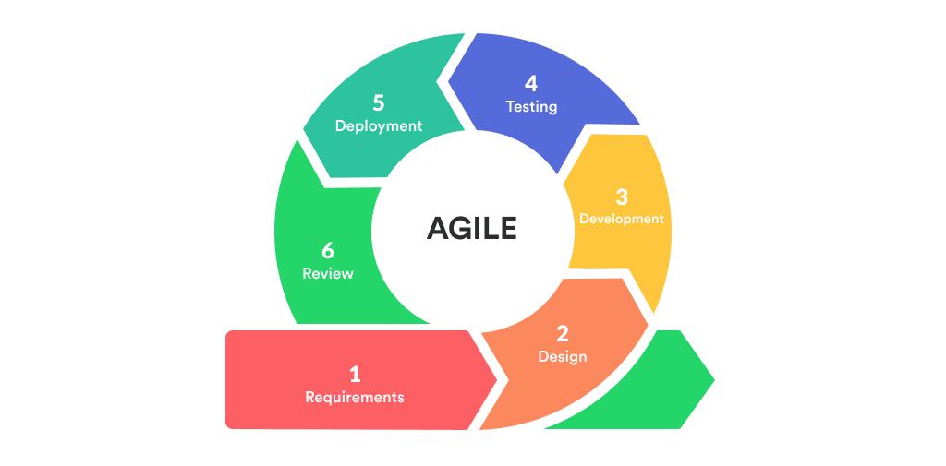
Systems Development Methodology
Figure 2. Agile Methodology
Agile Development Methodology
The researchers will utilize the Agile methodology for this capstone project (Schwaber & Sutherland, 2020). Agile is an iterative approach to software development that delivers work in small, manageable increments called sprints. It emphasizes collaboration, flexibility, and continuous feedback, allowing teams to adapt to changing requirements throughout the project.
Agile was selected because the system requires regular user feedback from the Sharon Store management regarding the Point of Sale (POS) interface and inventory workflows. By utilizing short cycles and constant communication, the system can receive continuous feedback for further improvements and refinements, ensuring that the final checkout and forecasting modules perfectly align with the fast-paced nature of the public market.
Requirement & Analysis
This phase begins with establishing definitive system requirements using data acquired from structured interviews with the two (2) store owners and eight (8) operational employees, combined with direct observations of the current manual logbook workflow. The needs analysis maps out these physical data bottlenecks and converts them into technical specifications. The technical analysis takes into account software aspects tailored for a local deployment, selecting an offline-first XAMPP environment (Apache server), PHP via PDO for backend operations, HTML5, CSS3, Vanilla JavaScript, and Bootstrap 5.3.0 for a highly responsive user interface, and MySQL for relational database management. It also considers strict hardware requirements, ensuring that the system interfaces seamlessly with desktop/laptop terminals (minimum 8GB RAM) and standard USB or Bluetooth barcode scanners to support rapid front-end cashier processing.
System Design
After obtaining all of the requirements, the system's technical architecture is meticulously planned out. Visual modeling tools are utilized to generate data flow diagrams (DFD Level 0 and Level 1), use case diagrams, and localized database designs that clearly define data trajectories and user permission boundaries. This stage entails designing a secure database structure across specific relational tables (such as tbl_inventory, tbl_transactions, and tbl_forecasts) to systematically handle product categories, stock counts (pieces, packs, or kilograms), real-time low-stock levels, and approaching expiration dates. User interface mockups are structured to prioritize large, clear text displays and intuitive navigation buttons, ensuring cashiers can execute checkouts swiftly during peak market rushes without causing customer delays.
Implementation
The system's actual coding begins during the implementation phase. Based on the logical rules set during the design stage, the developers construct the application modules iteratively. Primary development focus is channeled into programming the comprehensive System Admin (Owner) Module—including the real-time data visual charts for the Business Intelligence Dashboard, the predictive sales forecasting script based on historical transaction logs, and the database backup and audit trail tools. Concurrently, the Staff (Cashier) Module is coded, focusing heavily on embedding standard barcode-scanning scripts into the Point of Sale (POS) checkout line and establishing automated, real-time inventory deductions upon finalized sales.
Testing
During the testing phase, the system is evaluated for processing errors and its operational efficiency is confirmed. To ensure that all core features such as real-time low-stock warnings, instant total amount calculations, and historical demand data projections work flawlessly under load, a multi-tiered testing methodology is employed. This includes isolated Unit Testing of code blocks, Integration Testing of connected database tables, and User Acceptance Testing (UAT) conducted directly by the workforce within the Sharon Store locale. Any data mismatch, scanner latency, or calculation anomalies identified during these rounds are completely resolved before final system verification.
Development
Throughout the active timeline, the development phase consists of continuously improving the system infrastructure based on incremental layout evaluations and stakeholder feedback. The application is built on a local server backend managed via XAMPP, which handles critical server-side functions like data entry tracking, hardcopy report generation requests, and sales forecasting analytics. Front-end frameworks like Bootstrap 5.3.0 and Font Awesome 6.5.0 are utilized to maintain a clean, user-friendly, and modern visual display. Following the deployment of early test increments, new feature tweaks and dashboard optimizations are pushed out based directly on manager and cashier evaluations, ensuring the system perfectly fits the fast-paced nature of a public market grocery store.
Maintenance
Ongoing maintenance is required once the software is fully implemented at the store locale to address operational bugs, secure historical data, or adjust parameters over time. Maintenance protocols guarantee that the web application will continue to remain secure, functionally stable, and pertinent to the business's daily operations. This phase includes monitoring database indexing efficiency as transaction counts grow, rolling out localized bug patches, verifying that daily automated database backups function smoothly, and updating system thresholds for low-stock triggers as store inventory expands.
Review
After the system has been in continuous deployment for a designated period, a formal review step is executed to evaluate its overall performance impact against the old paper-based methods. Quantitative and qualitative feedback is gathered from both technical evaluators (I.T. Experts) and end-users (Management and Staff) using evaluation tools structured around the ISO/IEC 25010 software quality model. This step measures actual efficiency gains, such as checkout transaction speed improvements, the accuracy of generated restocking recommendations, and general user learnability. Noted areas of optimization are cataloged as data references for future system updates.
Launch
The system is formally launched for live business operations following final data clearing and environment optimization. During this stage, the manual paper logbooks are retired, and the program becomes the central hub for all active retail and wholesale grocery transactions at Sharon Store. The research team provides close post-launch on-site support during the first week of implementation to monitor barcode scanner responsiveness, assist cashiers during peak market rushes, and ensure maximum system stability under actual, real-world conditions.

Participants
Participants of the study are individuals, groups, or organizations who are actively involved in a research project and from whom the researcher collects data to evaluate the system. For this study, the participants are strictly categorized into the individuals directly involved in the operations of Sharon Store and their active patrons.
The participants are divided into three specific groups:
- The Management (2 Owners): The co-owners of the business who handle wholesale purchasing decisions, profit monitoring, and administrative control.
- The Operational Staff (8 Employees): The frontline workers responsible for manning the checkout counters, scanning barcodes, and physically restocking the fast-moving consumer goods.
- The Customers (Patrons): The retail and wholesale buyers who purchase goods from the store. Their participation is necessary to evaluate the speed of the new barcode-enabled Point of Sale (POS) system and the clarity of the on-screen digital receipt summary.
- IT Experts (3 Evaluators): Three independent Information Technology professionals will be purposively selected to conduct the Alpha Testing. Their participation is necessary to technically validate the system's architecture, database integrity, and security using the ISO/IEC 25010 framework.

Sampling Method
To select the appropriate respondents for the study, Purposive Sampling will be utilized for the internal workforce. In purposive sampling, participants are chosen on purpose because they have specific knowledge, experience, or characteristics relevant to the study. The internal participants are strictly drawn from the existing workforce of Sharon Store, consisting of exactly 10 participants. This includes the two (2) store owners (Management) and the eight (8) employees (Staff), who will provide expert operational insights regarding the daily checkout process, stock monitoring, and the usability of the Point of Sale (POS) and Business Intelligence modules.

For the Customers, Convenient Sampling will be utilized. To determine the exact number of customer respondents needed to evaluate the checkout efficiency without disrupting daily business, the researchers calculated the sample size based on an estimated population of 180 regular weekly patrons.
To determine the exact sample size for the customers, Slovin's Formula was applied using a standard 5 percent (0.05) margin of error (Tejero, 2023).
Slovin's Formula:
$n = \frac{N}{1+Ne^{2}}$
Where:
n = Number of samples
N = Total population
e = Error tolerance (0.05)
Computation for Customer Participants:
Given:
N = 180
e = 0.05
$n = \frac{180}{1+180{(0.05)}^{2}}$
$n = \frac{180}{1+180(0.0025)}$
$n = \frac{180}{1+0.45}$
$n = \frac{180}{1.45}$
n = 124.14
Rounding up to the nearest whole number, a total of 125 customers will be randomly selected to participate in the beta evaluation of the system's checkout speed and on-screen display clarity.
Therefore, the total number of participants for this study will be 138 (2 Owners, 8 Staff, 125 Customers, and 3 IT Experts).
Procedure
To systematically execute this study and ensure the technical validity of the web-based system, the researchers will follow a structured, three-phase procedural framework consisting of data gathering, data processing, and system evaluation.

Data Gathering Phase
The data gathering process will begin after securing formal administrative clearance via the Letter of Approval to Conduct Capstone Project from the management of Sharon Store. The researchers will utilize three distinct techniques to collect the necessary qualitative and quantitative baselines:
- Structured Interviews: The researchers will conduct on-site structured interviews with the two (2) managing owners to document operational financial risks, stock spoilage pain points, low-stock alerts, and forecasting parameters. Concurrently, the eight (8) operational staff members will be interviewed to assess front-end checkout line bottlenecks. The questionnaire tools are categorized in Appendix C: Interview Questions.
- Documentary Analysis: The researchers will audit existing physical logbooks and historical transaction sheets spanning from recent operational periods to extract real-world product categorization and retail metrics essential for seeding the forecasting modules.
Data Processing and System Development Phase
Once the raw qualitative and quantitative data are collected, they will be processed into technical assets using the Agile Development Methodology framework:
- Data Cleaning: Historical transaction entries extracted from the logbooks will be digitized and sorted into structural categories (canned goods, dry commodities, household essentials) to establish baseline parameters for the moving average calculation script.
- Database Normalization: The structural data will be mapped out into specific relational tables within MySQL, linking product parameters to transaction details via strict Primary Key (PK) and Foreign Key (FK) constraints.
- Iterative Sprints: Using PHP for backend mechanics and Bootstrap 5.3.0 for the frontend UI, the development team will build and refine system features based on iterative stakeholder feedback loops, integrating the barcode scanner hardware with the Point of Sale module.

System Evaluation Phase
To assess the quality and performance of the developed system, two sets of evaluation tools will be created based on the ISO/IEC 25010 software quality model. This international standard defines eight main quality characteristics for evaluating software: Functional Suitability, Performance Efficiency, Compatibility, Usability, Reliability, Security, Maintainability, and Portability.
- Alpha Test: The first set of evaluation tools will be administered to I.T. experts and will cover all system characteristics and sub-characteristics. This evaluation will provide technical validation and ensure that the database and system architecture meet required specifications.
- Beta Test: The second set of evaluation tools will be designed for the intended end-users (the management and staff of Sharon Store). This tool will contain only selected metrics relevant to the system's application, allowing the users to provide feedback on usability, functionality, and overall experience.
The combined results from the alpha and beta evaluations will be analyzed to identify strengths, weaknesses, and potential enhancements, ensuring that the system is both technically sound and user-friendly before final deployment.

Data Analysis
Data analysis is the process of systematically organizing, summarizing, and interpreting the information collected in a research study to transform raw data into meaningful results. The following statistical treatments will be used to analyze the evaluation data:
- Likert Scale: A Likert scale is a type of rating scale commonly used in surveys and evaluations to measure attitudes, opinions, or perceptions. The respondents will rate the system using a 5-point scale:
Table 1. Likert Scale
Scale | Meaning
5 | Excellent
4 | Very Good
3 | Good
2 | Fair
1 | Poor
- Frequency Count Distribution: Frequency count distribution shows how many times each response or category occurs in the data set. It will simply count the number of respondents who chose each Likert option, showing the raw response pattern of the evaluation.
- Percentage Distribution: Percentage distribution will be used to summarize responses and show the proportion of respondents choosing each rating. The formula is: Percentage = (Frequency / Total Respondents) * 100
- Table for Interpreting the Scores: To translate the numerical results (weighted mean) into descriptive terms that are easier to understand, the following reference table will be used:
Table 2. Score Interpretation
Weighted Mean Range | Interpretation
4.50 - 5.00 | Excellent
3.50 - 4.49 | Very Good
2.50 - 3.49 | Good
1.50 - 2.49 | Fair
1.00 - 1.49 | Poor

Design and Implementation

Requirements Specification Analysis
This part covers the functional requirements of the system, describing the specific tasks, features, or services it provides to meet user needs.
System Admin (Owner) Module
- Manage Accounts: Allows the admin to create and manage cashier accounts.
- Business Intelligence Dashboard: Provides real-time visual charts of sales trends and fast-moving grocery items.
- Inventory Management: Allows the admin to add, update, and delete grocery items, categorizing them and tracking stock levels.
- Sales Forecasting: Analyzes historical transaction data to generate predictive restocking recommendations.
- Database Backup: A tool that will be used to make daily backup of the system and database.
- Audit Trail: This will be used as a monitor and tracking tool as it will record all logs and changes of the users of the system.
Staff (Cashier) Module
- Point of Sale (POS): A rapid transaction interface that utilizes barcode scanning to instantly process customer purchases and automatically deduct sold items from active inventory.
- Stock Monitoring: A read-only interface allowing cashiers to view stock availability and receive low-stock alerts without editing privileges.

System Design and Specification
User Interface Design
This portion of the study presents the system's interactive screens, visual form inputs, and custom generated reports. The actual UI forms are optimized for high-contrast viewing and big touch-friendly button layouts to ensure high operability in public market environments. (The sample screenshots and generated UI reporting forms are thoroughly detailed across the presentation materials).
Entity Relationship Diagram (ERD)
The entity relationship diagram depicts the structural blueprint and database logic of the system's relational tables. It maps out how transaction entities interact with user parameters and active stock records. The complete database mapping showing the tables (tbl_users, tbl_inventory, tbl_transactions, tbl_transaction_details, tbl_audit_logs, and tbl_forecasts) linked via Crow's Foot Notations is illustrated in Appendix I: Entity Relationship Diagram. (Coronel & Morris, 2018).
Logical Specifications
This section presents the different diagrams used in the study to visually represent the logical flow of the system. These diagrams are essential tools in the field of software development and system analysis, providing a clear map of user interactions and data movements:
- Data Flow Diagram (DFD): Used for analyzing data-oriented systems, the DFD will determine the flow of data within the system, identifying input, output, and transforming processes (Shelly & Rosenblatt, 2012). The system's data flows are illustrated in Appendix F: Data Flow Diagram Level 0 and Appendix G: Data Flow Diagram Level 1.
- System Flowchart: The flowchart graphically illustrates the flow of the whole system and the sequential execution of operational processes from login to logout, which is entirely separate from the conceptual framework (Valacich, George, & Hoffer, 2015). The step-by-step logic and routing for both the Admin and Cashier are illustrated in Appendix J: System Flowchart.
- Use Case Diagram: A behavioral diagram used to illustrate the interactions between the system's users (actors) and the system itself, detailing the specific functionalities, privileges, and boundaries assigned to the Admin and Cashier roles (Satzinger, Jackson, & Burd, 2016). This diagram is presented in Appendix H: Use Case Diagram.
Hardware Specifications
The physical devices and computing equipment used during the development and implementation phases are categorized in Table 3 below:
Table 3. Hardware Specification Table
Component | Minimum Specification | Recommended Specification (Actual Device Used)
Processor | Intel Core i3 @ 2.30 GHz (or AMD equivalent) | Intel Core i5 @ 3.00 GHz or higher
Memory | 8GB RAM minimum | 16GB RAM
Storage | 500GB Hard Disk Drive | 512GB Solid State Drive (SSD)
Input Devices | Standard Keyboard, Mouse | USB/Bluetooth Barcode Scanner, Keyboard, Mouse
Output Devices | Standard Monitor (1024x768) | Standard Monitor, Document Printer (for reports)

Software Specifications
The software development tools, languages, and backend architectures used to program and run the web application are structured across the environments outlined in Table 4:
Table 4. Software Specification Table
Environment Tier | Software Resource | Version / Specification
Frontend Languages | HTML5, CSS3, JavaScript | Native Web Standards
UI Frameworks | Bootstrap, Font Awesome | Bootstrap v5.3.0, Font Awesome v6.5.0
Backend Engine | PHP (Hypertext Preprocessor) | PHP 8.x
Database Server | MySQL | MySQL Relational Server Engine
Local Environment | XAMPP Stack | XAMPP with Apache Web Server

REFERENCES
Adame, Z. D., Gamo, L. N., Balitanas, E. G., Libo-on, G. J., Nacor, N. C., & Quimba, R. J. A. (2008). Computerized warehouse inventory tracking system. Central Philippine University. https://repository.cpu.edu.ph/handle/20.500.12852/2211
Adetula, A. A., & Akanbi, T. D. (2023). Beyond guesswork: Leveraging AI-driven predictive analytics for enhanced demand forecasting and inventory optimization in SME supply chains. International Journal of Science and Research Archive, 10(2), 1389–1406.
Amuharnis, Iswandi, Rahmi, L., & Adriyendi. (2026). Inventory forecasting information system using the weighted moving average method at Tita's store. Jurnal Kecerdasan Buatan Dan Teknologi Informasi, 5(1), 57–69.
Asian Development Bank. (2025). Digitalizing micro, small, and medium enterprises in the Philippines: A path to economic resilience. ADB Publications. https://www.adb.org/publications/digitalizing-msmes-philippines
Bautista, J. V., & Young, M. N. (2022). Effective inventory management system in efficient supply and distribution management in one of manufacturer of food seasoning products in the Philippines. ICIII Conference.
Bonto, G., et al. (2025). Sentimart: Web-Based ordering, inventory & feedback system. International Journal of Research and Innovation in Applied Science (IJRIAS).
Coronel, C., & Morris, S. (2018). Database systems: Design, implementation, & management (13th ed.). Cengage Learning.
Custodio, N. C., et al. (2026). Predictive sales and inventory system with customer segmentation. International Journal of Research and Innovation in Applied Science (IJRIAS).
Department of Trade and Industry. (2024). Philippine retail industry roadmap 2024-2028: Empowering local markets and fast-moving consumer goods. https://www.dti.gov.ph/resources/retail-roadmap-2024
F1000Research. (2024). Improving inventory control through a web-based system in a retail enterprise. F1000Research, 13(252). https://f1000research.com/articles/13-252
German, V. K. P. (2016). Mobile POS application with cloud computing inventory management system. WCSE Conference.
Ghosh, D., Khanra, A., Vanamalla, S. V., Hamid, F., & Sengupta, R. N. (2022). Studies in quantitative decision making. In Asset analytics.
Gunderson, M., Boehlje, M., Neves, M., & Sonka, S. (2014). Agribusiness organization and management. In Elsevier eBooks (pp. 51–70).
International Organization for Standardization. (2011). ISO/IEC 25010:2011 Systems and software engineering — Systems and software Quality Requirements and Evaluation (SQuaRE) — System and software quality models. https://www.iso.org/standard/35733.html
Khojasteh, Y., & Jahan Abadi, S. M. (Eds.). (2026). Emerging technologies in supply chains. International Series in Operations Research & Management Science. Springer. https://doi.org/10.1007/978-3-032-01218-0
Ladani, J., Sanodiya, M., Thakur, S., Kadoo, T., & Pandey, K. (2025). Web based inventory and warehouse management system. In Information systems engineering and management (pp. 181–192).
Library & Information Science Academy. (2024). Research design: The blueprint of methodology and data interpretation. LIS Academy Publications.
Maglinte, J. B., Dela Cerna, A. A., Tapitan, M. R. G., Sulidarios, M. Z. L., & Talirongan, H. (2025). A system engineering approach to enhance operational efficiency in a state college food court through an integrated POS and inventory platform. International Journal of Engineering Technology Research & Management (IJETRM), 9(12).
Nasution, N., Sitompul, D. R., & Walhidayat, W. (2023). Application of sales forecasting using the least square method in Web-Based information systems. JURNAL TEKNOLOGI DAN OPEN SOURCE, 6(1), 11–22.
Nicholas, A., Yuana, H., & Rahmat, M. F. (2025). Design of a website-based goods inventory information system at the grocery store. Journal of Advances in Information and Industrial Technology, 7(1), 31–44.
Panganiban, E. B., & Bermusa, J. P. (2020). Simplified barcode-based point of sales and inventory management system with replenishment decision. International Journal of Scientific & Technology Research, 9(3).
Permatahati, I., & Muqorobin, M. (2022). Computer sales forecasting system application using web-based single moving average method. International Journal of Computer and Information System (IJCIS), 3(2), 56–63.
Satzinger, J. W., Jackson, R. B., & Burd, S. D. (2016). Systems analysis and design in a changing world (7th ed.). Cengage Learning.
Schwaber, K., & Sutherland, J. (2020). The Scrum Guide: The definitive guide to Agile project management. Scrum.org. https://scrumguides.org/.
Shelly, G. B., & Rosenblatt, H. J. (2012). Systems analysis and design (9th ed.). Course Technology, Cengage Learning.
Subianto, T. A. D. P., Wiratama, J., & Halim, F. A. (2023). The development of web-based cashier and inventory information systems using prototyping model on Micro, Small, and Medium Enterprise (MSMEs) in Indonesia. JOINS (Journal of Information System), 8(1), 80–89.
Suya, J., Rodillas, G. C., Tubog, X. J., & Doctor, R. C. (2026). Sort Out: A smart inventory management system using descriptive analytics and rule-based algorithm for mini grocery stores. International Journal of Research and Innovation in Applied Science (IJRIAS).
Tanaman, M. T., Baylosis, J. L. A., Abiles, B. J. A., Catungal, M. L. P., & Encarnacion, P. C. (2023). Web-based inventory management system. International Journal of Science and Applied Information Technology.
Tejero, E. G. (2023). Statistical methods and Slovin's formula in descriptive research design. Journal of Applied Business Statistics.
United Nations. (2024). The sustainable development goals report 2024. Department of Economic and Social Affairs. https://unstats.un.org/sdgs/report/2024/
Valacich, J. S., George, J. F., & Hoffer, J. A. (2015). Essentials of systems analysis and design (6th ed.). Pearson.
Villanueva, J. C., & Reyes, M. L. (2025). Transitioning from manual logbooks to web-based inventory systems in Philippine public markets. Journal of Information Systems and Business Management, 8(4), 112-128.


Appendix A: Adviser’s Commitment and Agreement


Appendix B: Letter of Approval to Conduct Capstone Project
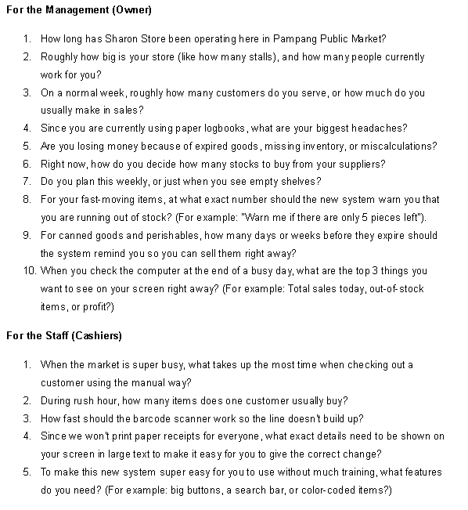
Appendix C: Interview Questions

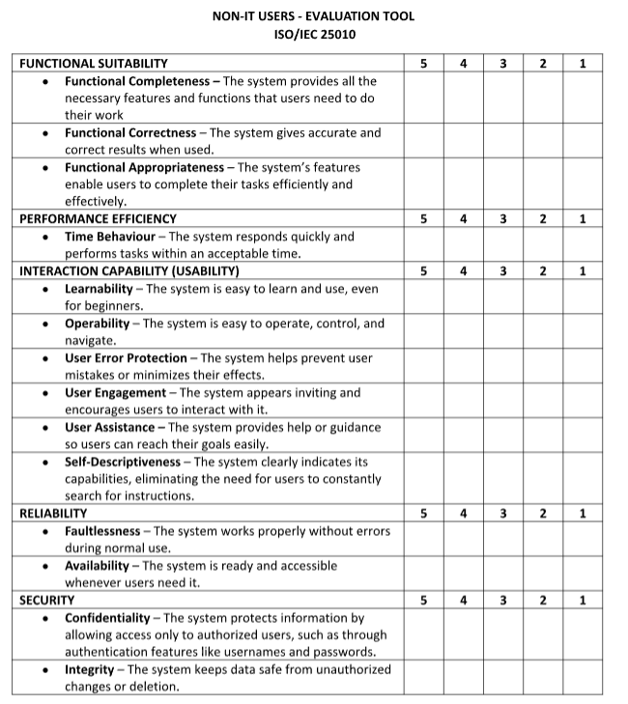
Appendix D: Evaluation Tool (Non-IT)

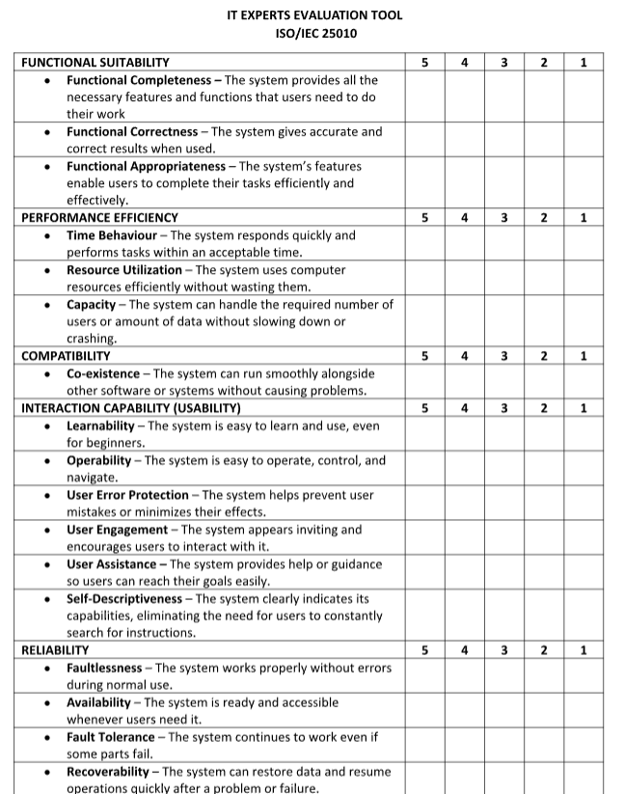
Appendix E: Evaluation Tool (IT Experts)

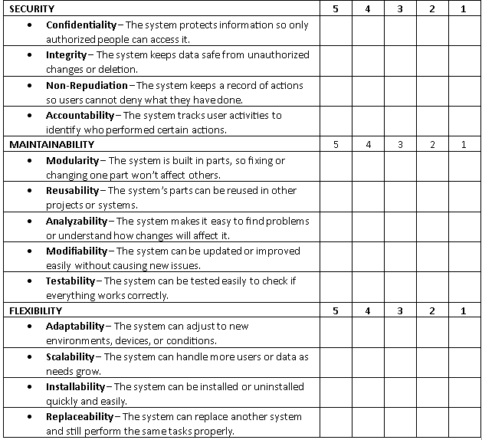

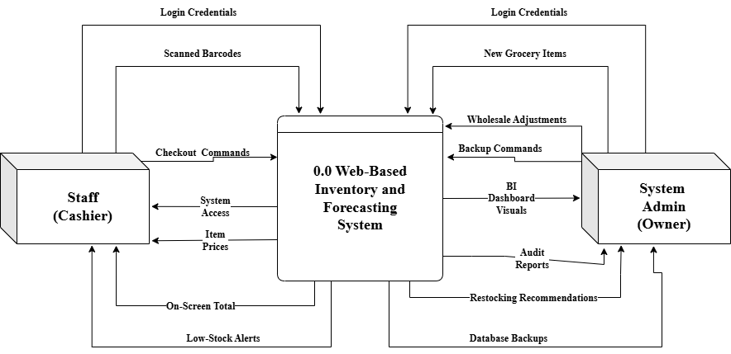
Appendix F: Data Flow Diagram Level 0
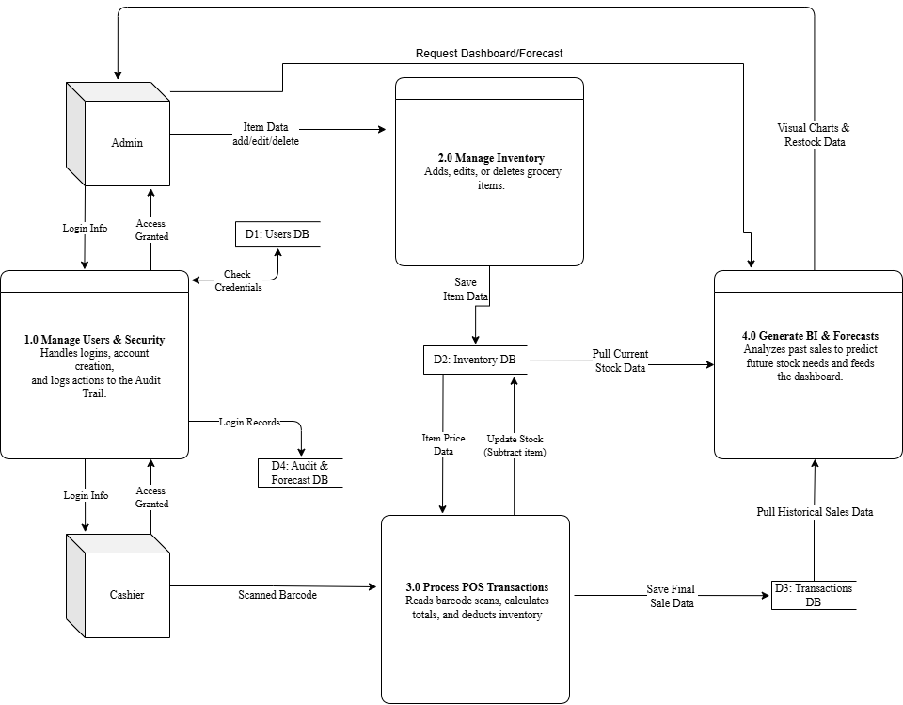
Appendix G: Data Flow Diagram Level 1

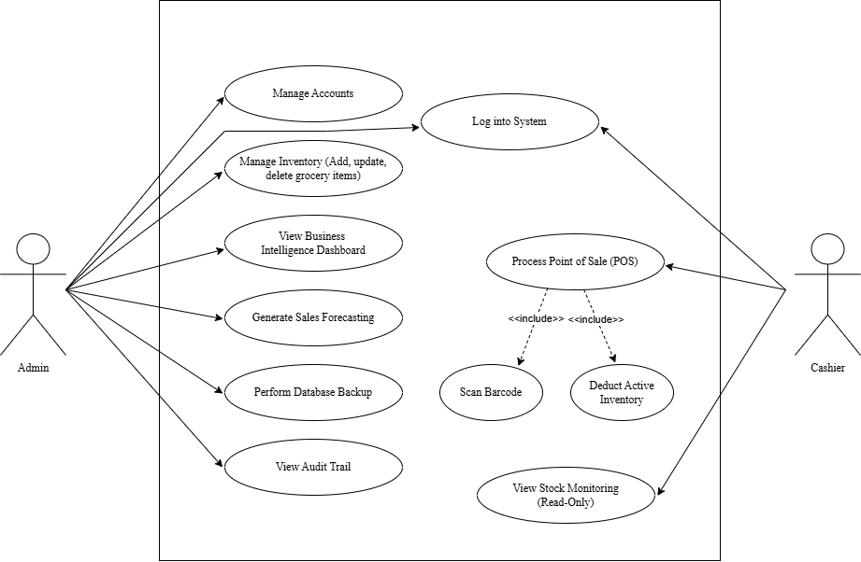
Appendix H: Use Case Diagram
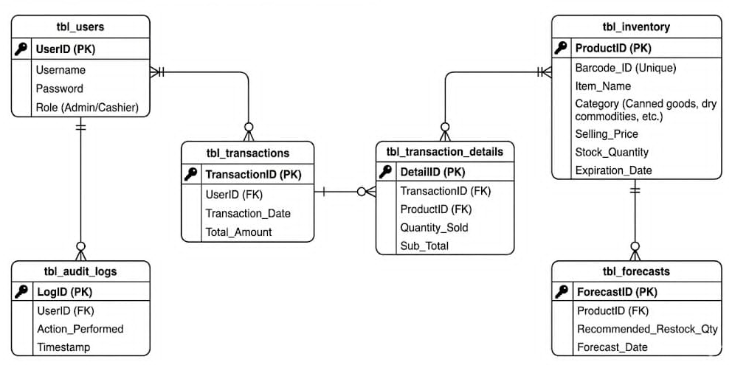
Appendix I: Entity Relationship Diagram
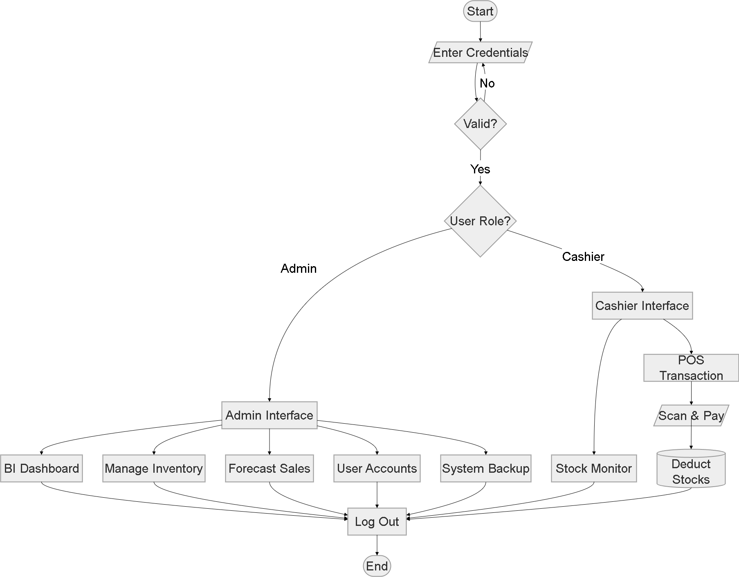
Appendix J: System Flowchart
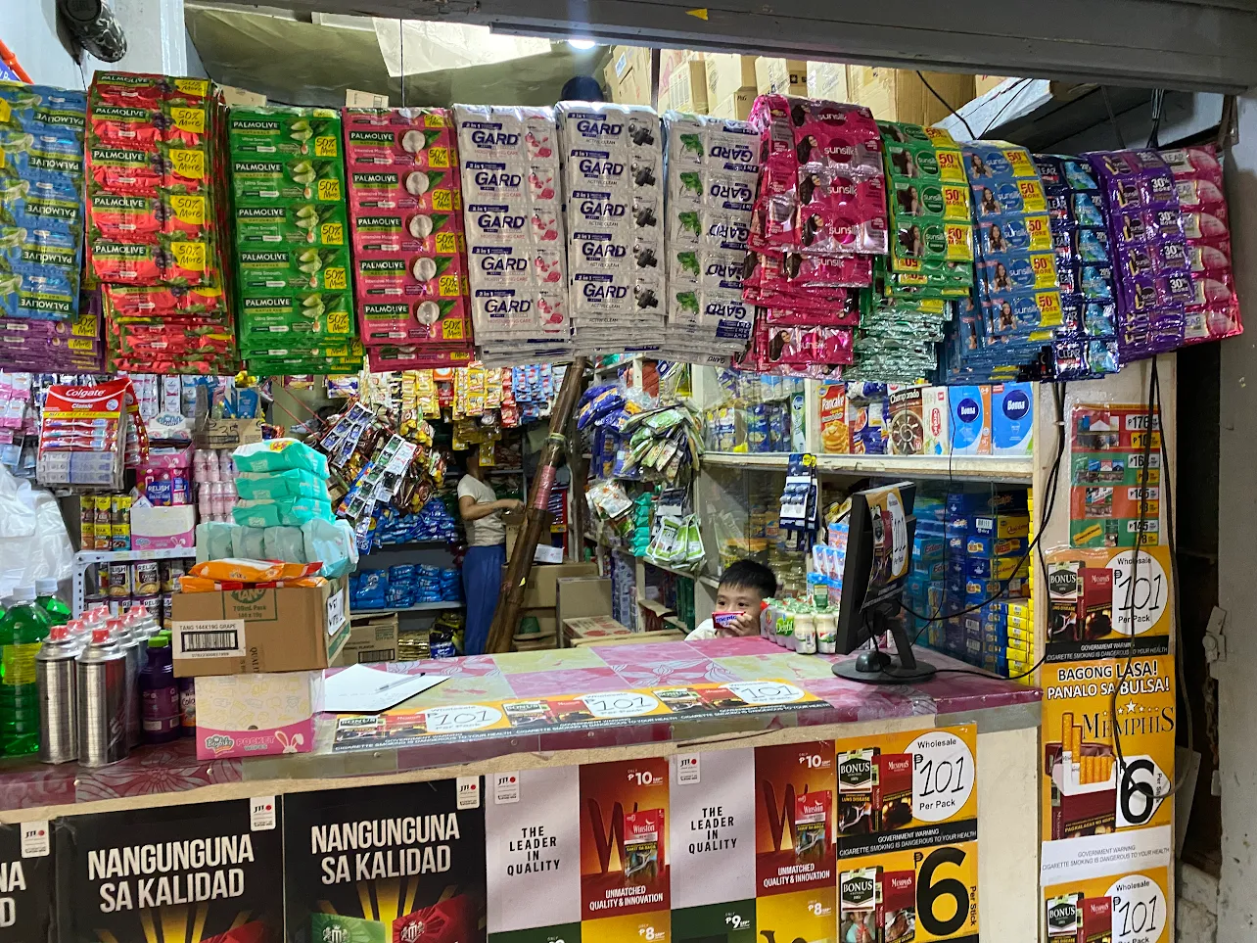
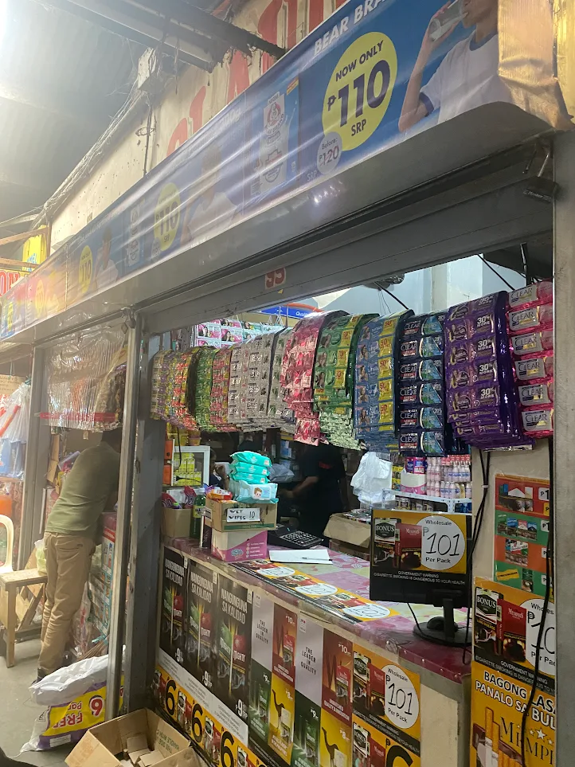
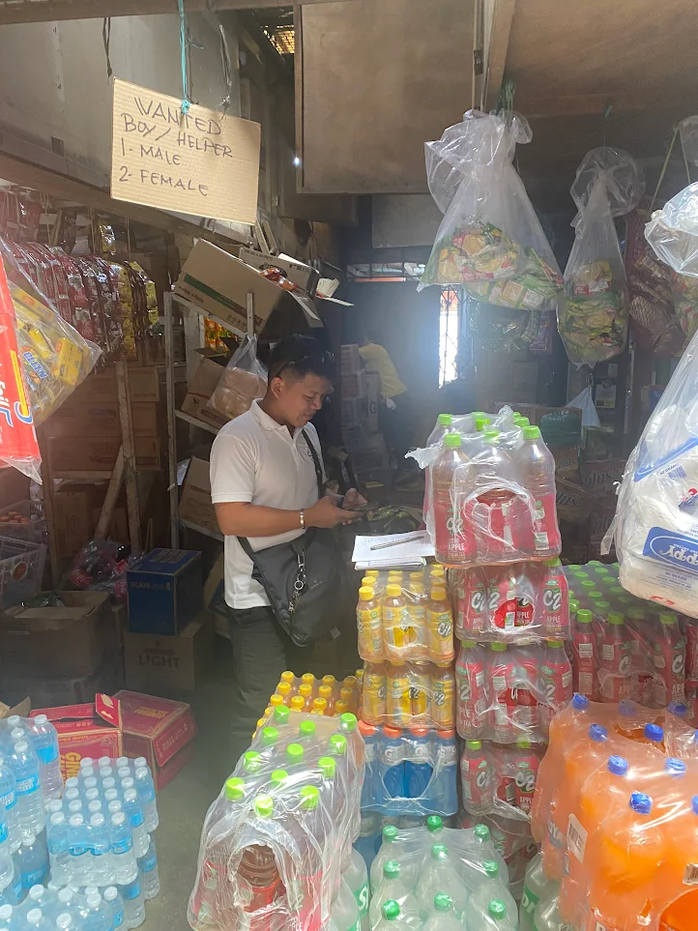
Appendix K: Documentation of the Research Locale.

